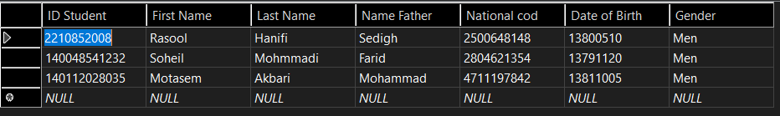

CREATE TABLE [dbo].[Student]

(

[ID Student] BIGINT NOT NULL,

[First Name] NVARCHAR (50) NOT NULL,

[Last Name] NVARCHAR (50) NOT NULL,

[Name Father] NVARCHAR (50) NOT NULL,

[National cod] BIGINT NOT NULL,

[Date of Birth] INT NOT NULL,

[Gender] NVARCHAR (50) NOT NULL,

PRIMARY KEY CLUSTERED ([ID Student] ASC)

);

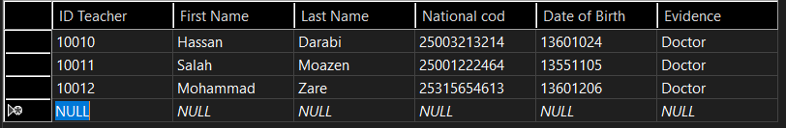

CREATE TABLE [dbo].[Teacher]

(

[ID Teacher] BIGINT NOT NULL,

[First Name] NVARCHAR (50) NOT NULL,

[Last Name] NVARCHAR (50) NOT NULL,

[National cod] BIGINT NOT NULL,

[Date of Birth] INT NOT NULL,

[Evidence] NVARCHAR (50) NOT NULL,

PRIMARY KEY CLUSTERED ([ID Teacher] ASC)

);

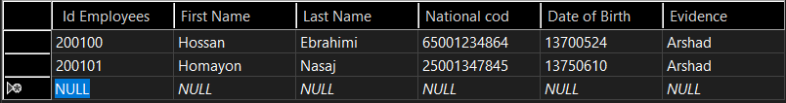

CREATE TABLE [dbo].[Employees]

(

[ Id Employees] BIGINT NOT NULL,

[First Name] NVARCHAR (50) NOT NULL,

[Last Name] NVARCHAR (50) NOT NULL,

[National cod] BIGINT NOT NULL,

[Date of Birth] INT NOT NULL,

[Evidence] NVARCHAR (50) NOT NULL,

PRIMARY KEY CLUSTERED ([ Id Employees] ASC)

);

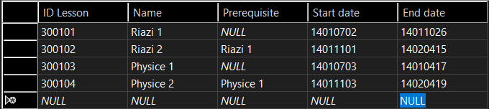

CREATE TABLE [dbo].[Lesson]

(

[ID Lesson] INT NOT NULL,

[Name] NVARCHAR (50) NOT NULL,

[Prerequisite] NVARCHAR (50) NULL,

[Start date] INT NOT NULL,

[End date] INT NOT NULL,

PRIMARY KEY CLUSTERED ([ID Lesson] ASC)

);

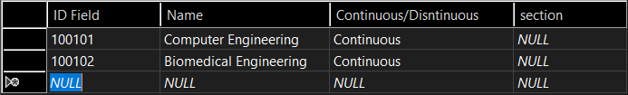

CREATE TABLE [dbo].[Field]

(

[ID Field] INT NOT NULL,

[Name] NVARCHAR (50) NOT NULL,

[Continuous/Disntinuous] NCHAR (10) NOT NULL,

[section] NVARCHAR (50) NULL,

PRIMARY KEY CLUSTERED ([ID Field] ASC)

);

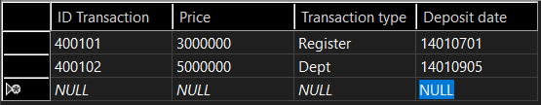

CREATE TABLE [dbo].[Transaction]

(

[ID Transaction] INT NOT NULL,

[Price] BIGINT NOT NULL,

[Transaction type] NVARCHAR (50) NOT NULL,

[Deposit date] NVARCHAR (50) NOT NULL,

PRIMARY KEY CLUSTERED ([ID Transaction] ASC)

);

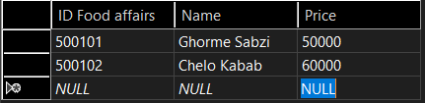

CREATE TABLE [dbo].[Food affairs]

(

[ID Food affairs] INT NOT NULL,

[Name] NVARCHAR (50) NOT NULL,

[Price] INT NOT NULL,

PRIMARY KEY CLUSTERED ([ID Food affairs] ASC)

);